Assessment 1 & 2 screenshots with docker-compose.yml file

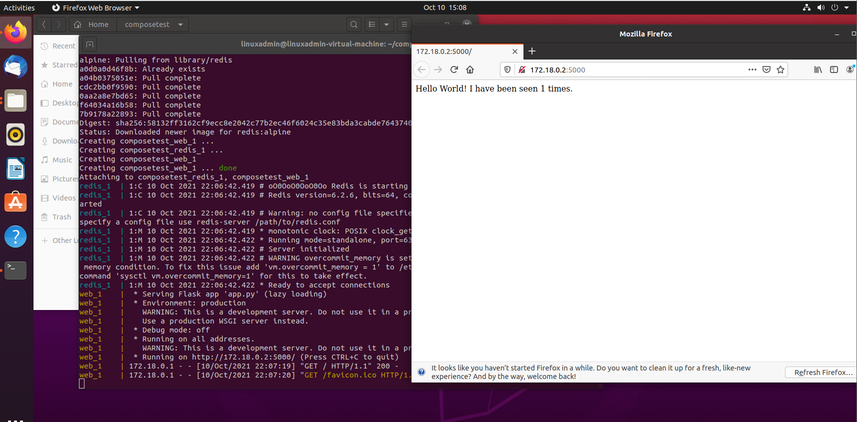

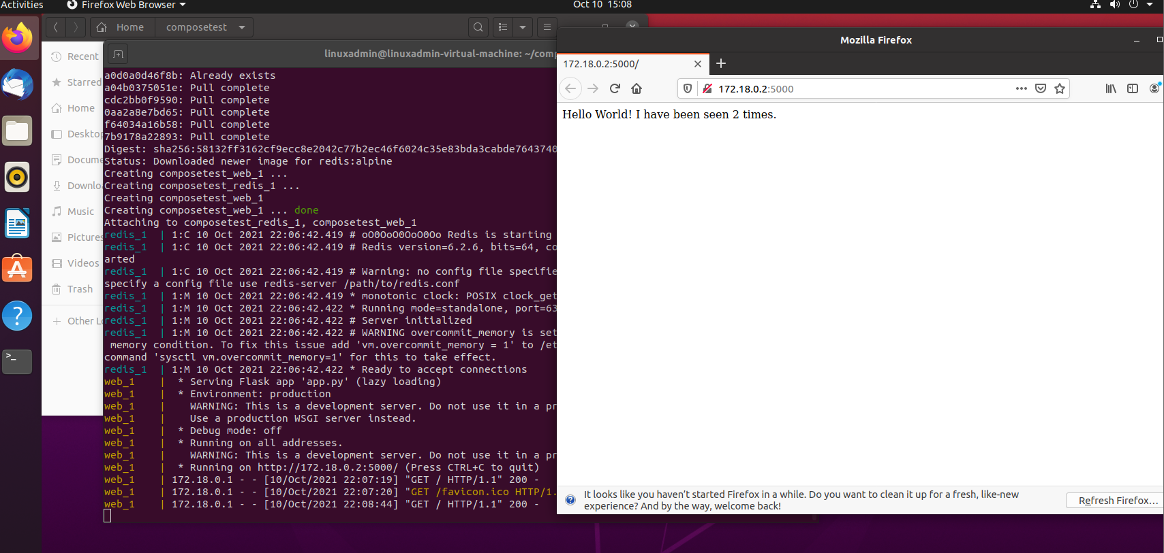

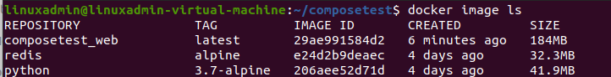

Below is the docker-compose.yml for redis with memory and CPU restriction and authentication enabled for redis.

